Accessibility Links
Skip to content

Search The Times and The Sunday Times

Today’s sections Past six daysMy articles
Times+
My account

Enterprise flourishes on blooms from bin
Lianne Kolirin
February 11 2019, 12:01am, The Times
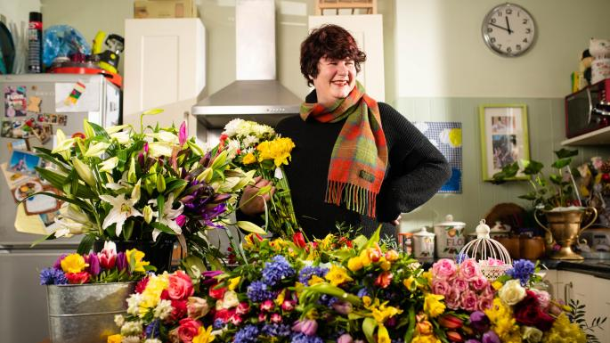
Ursula Stone collects unsaleable flowers from supermarkets and creates stunning displays to sell and to brighten up the lives of dementia patientsJOHN NGUYEN/JNVISUALS
Share
Save
The Flower Bank blossomed from unlikely beginnings: a redundancy and a pauper’s funeral.
Two years after it started at a kitchen table it has become a thriving social enterprise thanks to crowdfunding that raised almost £70,000, as well as grants and lottery funds.
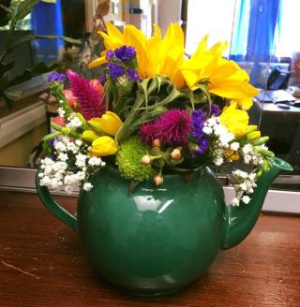
Ursula Stone, 51, gathers flowers and plants beyond their saleable date from supermarkets and other suppliers. She sorts out the good from the wilted and creates arrangements which she delivers to customers and to care homes and dementia centres. She often involves their patients in her work and is helped by members of a young offenders’ scheme on community service.
In 2014 she had been made redundant and took a floristry course that involved working on commercial projects.
“The waste that goes on in those places is amazing,” she said. “One client spent £10,000 on flowers that were up for a day. It really made me angry. Around that time a friend of mine died alone with no recourse to funds so he was given a pauper’s funeral. I went to the supermarket and saw they had reduced flowers. When I asked what happened at the end of the day I was told that they put them in the bin. So I took them and made a wreath and that’s how the Flower Bank started.”
Today she and her volunteers work with several supermarkets, and funeral arrangements are a big part of her work. “Working with flowers is incredibly therapeutic. The scent and colour of the flowers have helped evoke positive memories for the dementia patients. Meanwhile the young offenders develop a sense of calmness and learn new skills,” she said.
She now hopes to revamp a derelict high street shop and relaunch as a community florist and learning centre. Almost nine out of every ten pounds crowdfunded came from complete strangers, she said, and Crowdfund London, a campaign run by the mayor, invested £30,000.

