Woman collects unsellable flowers from supermarkets to brighten up the lives of dementia patients

'A lady was always asleep with the chair, and when I came she seemed really engaged by the flowers we made'

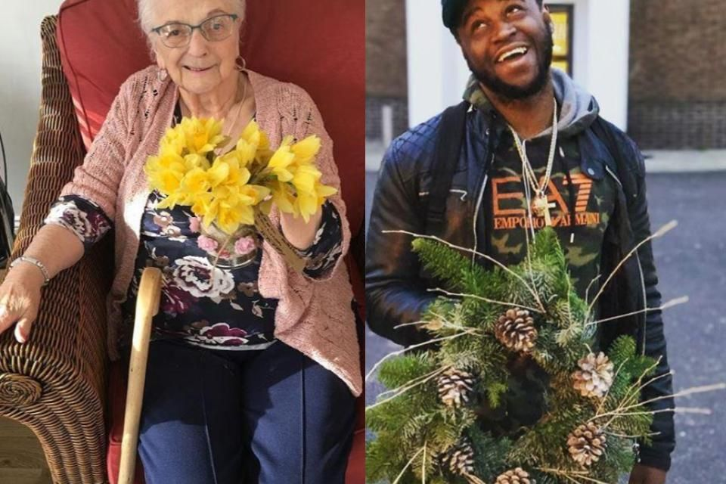A recipient of the lowers, and Mike, third year University of Middlesex student who has made wreaths as part of The Flower Bank project (Photo: Instagram/@the_flowerbank
Follow

She picks up unsellable flowers and gives them a new lease of life
- Ursula Stone also trains youth offenders at The Flower Bank
- 'The work is rewarding, innovative, and a unique solution to waste'
A woman who was made redundant has followed her dreams to become a florist and delivers flowers to dementia patients that have been taken from supermarket waste.
Ursula Stone, 51, works alongside young offenders to run The Flower Bank, a project which provides people in need with low-cost flowers and plants that would have been destined for the bin.

Delivered to dementia units
The florist picks up the flowers and plants at 10pm from supermarkets and other florists in north London to craft them for old people’s homes and those in need of flowers on a budget.
Ms Stone, who worked as an equality events organiser for Haringey council, was made redundant in 2014.
It was then the 51-year-old decided to re-train as a florist.
“I got the floristry bug, and started the business after training for two years in 2017,” Ms Stone told i.
“Supermarkets across north London donate me their flowers and plants. Maybe they’re over ordered, maybe their expiry date is approaching, so I go and collect them late in the evening if we have an order in,” she explains.
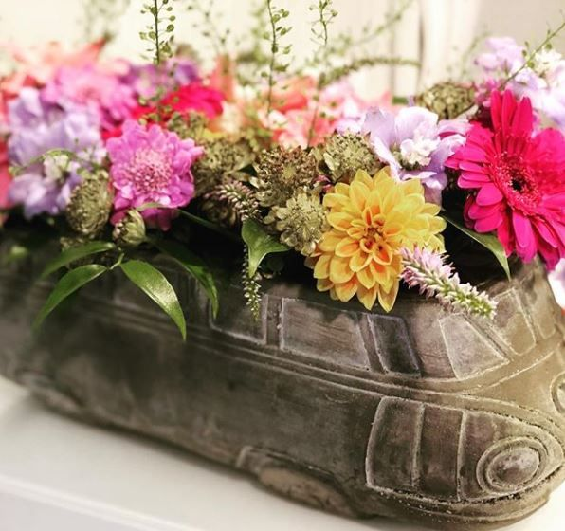

A flower arrangement made with the donated flowers (Photo: Instagram/@the_flowerbank
Follow)
“The flowers might be made into an arrangement who go onto the reception desks, or go into old people’s homes in dementia units.
“Others might want some funeral flowers that look good for the day, or just a quick bunch of flowers and don’t want to spend a fortune,” she added.

Helping young offenders
Although Ms Stone usually works out of her kitchen to make the arrangements, she also trains young offenders doing community service in The Flower Bank’s garden.
“Reparations for young offenders are too punitive. If someone’s punished without being given any steps to move forward, it won’t help,” Ms Stone told i.
“Young offenders with a creative eye enjoy the project, and it’s great to pass on a skill.
“We had one boy for five weeks. We saw a real development from the start to the end. It was tragic when he left,” she added.
And the project doesn’t just help reduce waste – it can have health benefits for patients receiving the flowers too.
Alzheimer’s Society believe that activities with flowers and plants can help people with the illness.
The NHS also advises keeping a selection of herbs and flowers in a dementia patient’s home to help them stay lively and engaged.
“One lady in one of the centres I work in always wants to go back to her room. But when she sees the flowers, she becomes fascinated and sits there quietly,” the florist told i.
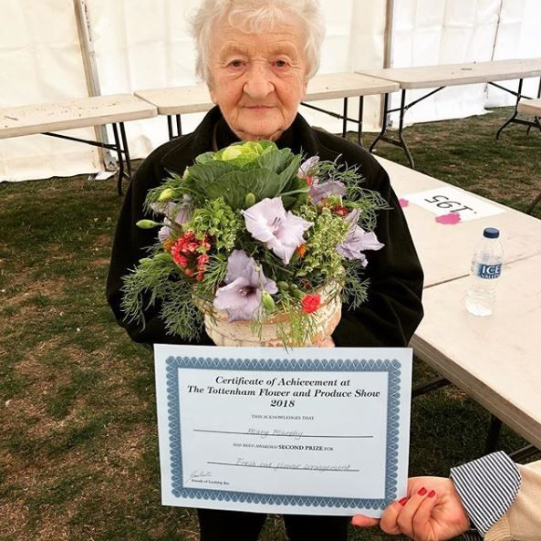
‘Last Friday I helped Mary and 7 other residents from Priscilla Wakefield House with their entries for Tottenham’s Flower & Produce Show – imagine the delight when Mary was awarded 2nd Prize,’ said Ms Stone (Photo: Instagram//@the_flowerbank)
“Another lady was always asleep with the chair, and when I came she seemed really engaged by the flowers.
“The colour and the smell of flowers seems to really help the patients. When we made a remembrance day wreath with a local home, a lot of older patients began speaking about the war, and their long-term memory came to the fore. It does seem to have a restorative effect,” she added.

Leaving the 9-5 grind
Now Ms Stone has plans to expand the business to get into the local community, she hopes to employ a group of florist enthusiasts and offer training courses for those who want to get involved.
She has advised those stuck in a rut to consider jobs that are “a bit more outside of the box.”
“You have this gut feeling when it comes to your job, and you know whether or not it’s right for you,” she told i.
“I’ve always felt a bit outside of the box and I’ve struggled with conforming – if you’re like me, I say do something about it!
“You meet so many interesting people when you’re outside an office environment. You can be yourself and set your own agenda.
“The work is rewarding, innovative, and a unique solution to waste.”

Jasmine Andersson 2 months Monday February 11th 2019
https://inews.co.uk/inews-lifestyle/work/woman-supermarket-flowers-dementia-patients/

